**Introduction**

The project entitled “BANKING MANAGEMENT SYSTEM” is a computerized telecommunications device that provides the customers of a financial institution with access to financial transactions in a public space without the need for a human clerk or bank taller (manpower).

Thousands of banks performs millions of transactions every day and thousands of users used banking system in day to day life. As we know that if number of users increases us need more banks and more staff it means increasing manual work also we put more amount of money in bank it is riskier and not much secure.

If we developed advanced computerized based banking system so there is no need to open more branches as well the manpower is reduced and maximum information are stored automatically in banking server.

In this system we provides user to create account into bank and do transactions. Also provides various features i.e. to withdrawal amount, Deposit amount, etc.

It is used to Keep the records of clients, employee etc in Bank. The bank management system is an application for maintaining a person’s account in a bank .

The system provides the access to the customer to create an account, deposit/withdraw the cash from his account, also to view reports of all accounts present and to change the pin of account of a user.

SCOPE OF PROJECT

* The scope of project “BANKING MANAGEMENT SYSTEM” is to support for daily update and maintain information of system.
* In this system we provide facilities such as maintains:-
* *Creating new user account.*
* *Deposit Amount.*
* *Withdrawal amount.*
* *Fast cash. (Withdrawal)*
* *Pin Change.*
* *Maintain Reports.*
* The scope of the Bank Management System extends to all the users who wish for easy banking facilities.
* This software will be used for storing user’s account information and the transactions made by them.
* A Computerized screen Banking System can be:
* *Fast*
* *Effective*
* *Safe*
* *User Friendly*

**Existing System**

* Existing system was carried out through manual process.
* Maintenance of the records in the existing system is difficult.
* Lot of time is taken to search for a particular record. There is a chance of occurrence of errors.
* Updating and retrieval of information in this existing system takes more time.
* Thought it has used information system, but it is totally a manual one and hence there is a need of upgrade the system to that of the computer based information system.
* Less security of customer and bank information.
* Require more physical work and man power. By digitalization in the banking system, it will not only achieve the goals of it and also will give some benefits like less manual calculation will be required.

***OBJECTIVES***

* **The main objectives of our work are:**
* Main Goals:
* Our motto is to develop a software program for managing the entire bank process related to Administration accounts customer accounts and to keep every track about their property and their various transaction processes efficiently.
* Hereby, our main objective is the customer’s satisfaction considering today’s faster in the world.
* Customer Satisfaction:
* Client can do his operations comfortably without any risk or losing of his privacy.
* Our software will perform and fulfil all the tasks that any customer would desire.
* Saving Customer Time:
* Client doesn't need to go to the bank to do small operation.
* Protecting the Customer:
* It helps the customer to be satisfied and comfortable in his choices, this protection contains customer’s account, money and his privacy.

**Proposed System**

* There is need to develop a new system to reduce a human stress & paper work which causes waste of time. The new system should concern the requirements of user are follows:
* *Different operation can generate report easily.*
* *Reduce complexity & increase the speed of project.*
* *System satisfying user requirements & improve efficiency.*
* *Provide accuracy in any operation.*
* It is difficult to achieve this goal using a manual system as the information is redundant, can be scattered & collecting relevant information may be very time consuming.
* It focuses on presenting information in an easy & intelligible manner which provides facilities like user registration and account creation of users thus reducing paper work and automating the record generation process in an banking system.

**HARDWARE AND SOFTWARE SPECIFICATION**

* **SOFTWARE REQUIREMENT:**
* **Operating system:** Windows XP/7/8/10.
* **Front end:** JAVA NetBeans-8.2.
* **Framework:** Swing and AWT.
* **Back end:** MySQL Server.
* **HARDWARE REQUIREMENT:**
* **Processor:** Intel ® Dual Core or above.
* **Primary memory(RAM):** 512 MB or above.
* **Secondary memory(ROM):** 40 GB or above.

**FEASIBILITY STUDY**

The feasibility study is the important step in any system development process. Because it makes analysis of different aspects like cost required for developing and executing the system, the time required for each stage of the system. If these important factors are not analysed then definitely it would be a total failure. So, for running the application and the organization successfully this step is a very important step in a software development lifecycle process. There are three types of feasibility analysis:

1) Operational Feasibility:-

* Operational feasibility measures how well the solution will work in the organization and how will end-user & management feels about the system. Proposed system is helpful for all the users associated with the organization.
* It will allow the administrator to have up-to-date information regarding all the aspects of their users, the decision-making process will also become faster with the BANK MANAGEMENT SYSTEM. So, it is feasible to implement the system.

2) Technical feasibility:-

* This involves questions such as whether the technology needed for the system exists, how difficult it will be to build, and whether the firm has enough experience using that technology.
* This system required minimum hardware equipment to run efficiently.

3) Economical feasibility:-

* Economically to find out whether this project is economically feasible or not for that used feasibility analyses.
* In this stage list direct costs or indirect costs associated with the project.

**FACT FINDING TECHNIQUES**

* Fact-finding is an important activity in system investigation. In this stage, the functioning of the system is to be understood by the system analyst to design the proposed system.
* Various methods are used for this and these are known as fact- finding techniques. The analyst needs to fully understand the current system.
* The analyst needs data about the requirements and demands of the project undertaken and the techniques employed to gather this data are known as fact-finding techniques.
* Various kinds of techniques are used and the most popular among them the personal observations made by the analyst himself.

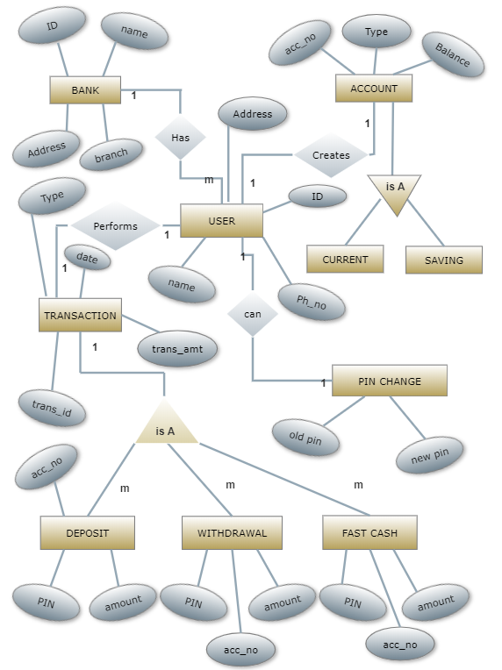

***Data Flow Diagram:***

1. A data flow (DFD) is a graphical system model that shows all of the main requirements for an information system in one data diagram: Inputs and outputs processes, and data storage.
2. A DFD describes what data flows rather than how it is processed.
3. Everyone working on a development project can see all aspects of the system working together at once with DFD.  That is one reason for its popularity.
4. The DFD is also easy to read because it is graphical model.
5. The DFD is mainly used during problem analysis. End Users, management, and all information systems workers typically can read and interpret the DFD with minimal training

***DFD SYMBOLS:***

* Process -:

* Data Flow -:
* External entity -:

* Data source -:

User

Transactions

Enquiry for Trans details

Bank

Management

Accounts details User

Creates Account

Deposit amt

Withdrawal amt

Queries

User details

Trans. details All Report

Reports

User

User details Update User Data

Bank Details Update Bank Data

Bank

Update Login & Signup

User

Personal Details

(Adhar/ PAN Card)

User

Card no & Pin update Login Data

Deposit

User

Withdrawal Update Bank Data

Bank

Trans. details

OLD PIN Update Login/

User

Signup/bank

NEW PIN

BANK

Verify OLD PIN

Refer Login

Daily updates

Refer Signup

Queries

Bank Management

Refer Transaction

Monthly Uses Report

Refer Pin generation

**USER ACCOUNT CREATION**

**SIGNUP 1**

|  |  |  |  |  |
| --- | --- | --- | --- | --- |
| Field No. | Attributes | Data Type | Size | Description |
| 1 | Form no | Integer  (Primary key) | 05 | Form no |
| 2 | Username | Varchar | 50 | Name |
| 3 | Father name | Varchar | 20 | Father name |
| 4 | Date | Integer | 03 | Date |
| 5 | Month | Varchar | 20 | Month |
| 6 | Year | Integer | 05 | Year |
| 7 | Gender | Varchar | 07 | Gender |
| 8 | Email | Varchar | 30 | Email |
| 9 | Marital | Varchar | 15 | Marital |
| 10 | Address | Varchar | 50 | Address |
| 11 | City | Varchar | 15 | City |
| 12 | Pin code | Integer | 10 | Pin code |
| 13 | State | Varchar | 20 | State |

**SIGNUP 2**

|  |  |  |  |  |
| --- | --- | --- | --- | --- |
| Field No. | Attributes | Data Type | Size | Description |
| 1 | Form no | Integer  (Primary key) | 05 | Form no |
| 2 | Religion | Varchar | 20 | Religion |
| 3 | Category | Varchar | 15 | Category |
| 4 | Income | Integer | 20 | Income |
| 5 | Education | Varchar | 20 | Education |
| 6 | Occupation | Varchar | 20 | Occupation |
| 7 | Aadhar No. | Integer | 20 | Aadhar No. |
| 8 | PAN No. | Integer | 20 | PAN No. |
| 9 | Senior | Varchar | 05 | Senior |
| 10 | Existing | Varchar | 05 | Existing |

**SIGNUP 3**

|  |  |  |  |  |
| --- | --- | --- | --- | --- |
| Field | Attribute | Data type | Size | Description |
| 1 | Form no | Integer  (Primary key) | 05 | Form no |
| 2 | Account | Varchar | 20 | Account |
| 3 | Card no | Integer | 15 | Card no |
| 4 | Pin | Integer | 15 | Pin |
| 5 | Service Required | Varchar | 10 | Service Required |

**LOGIN**

|  |  |  |  |  |
| --- | --- | --- | --- | --- |
| Field No. | Attributes | Data Type | Size | Description |
| 1 | Card No. | Integer  (Primary key) | 16 | card no |
| 2 | PIN | Integer | 05 | pin |

**TRANSACTION**

|  |  |  |  |  |
| --- | --- | --- | --- | --- |
| Field | Attribute | Data type | Size | Description |
| 1 | PIN | Integer  (Primary key) | 05 | Pin |
| 2 | DEPOSIT | Long | 40 | Deposit |
| 3 | WITHDRAWAL | Long | 40 | Withdrawal |
| 4 | BALANCE | Long | 40 | Balance |

*User Login Form:*

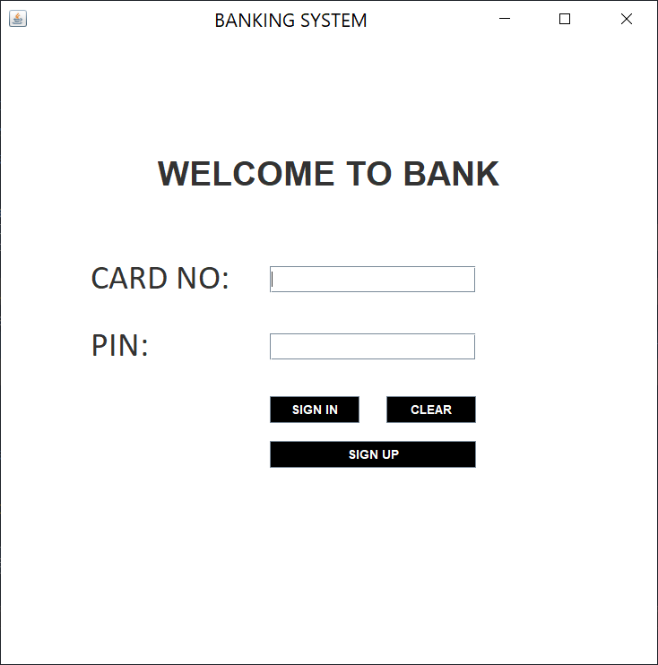

*User Login Process:*

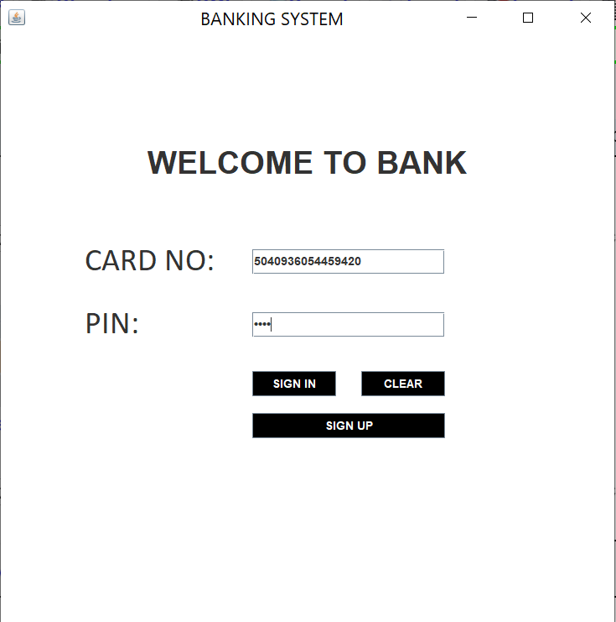

*MDI Form(Transaction):*

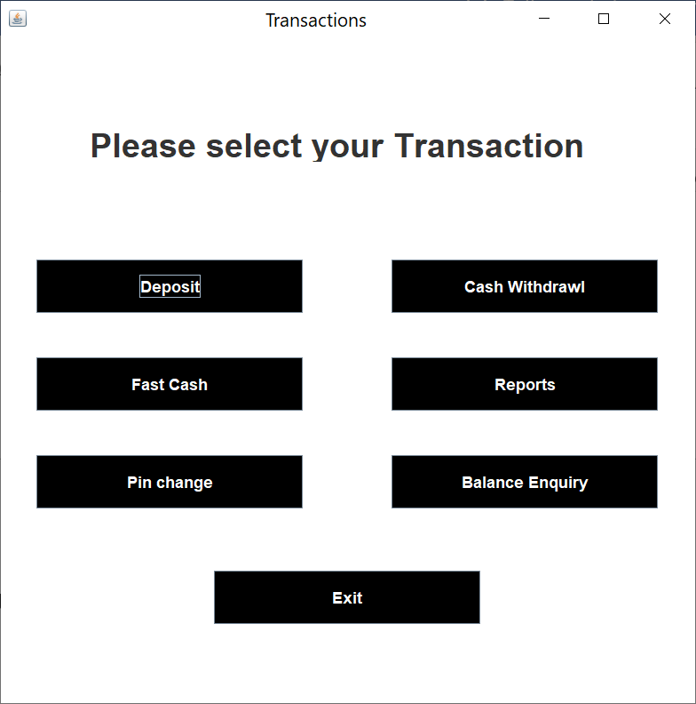

*Signup Form 1:*

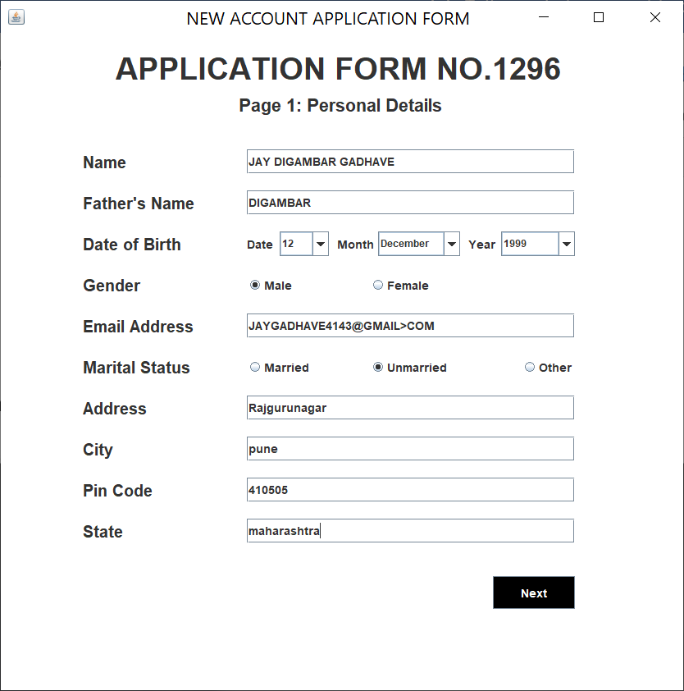

*Signup Form 2:*

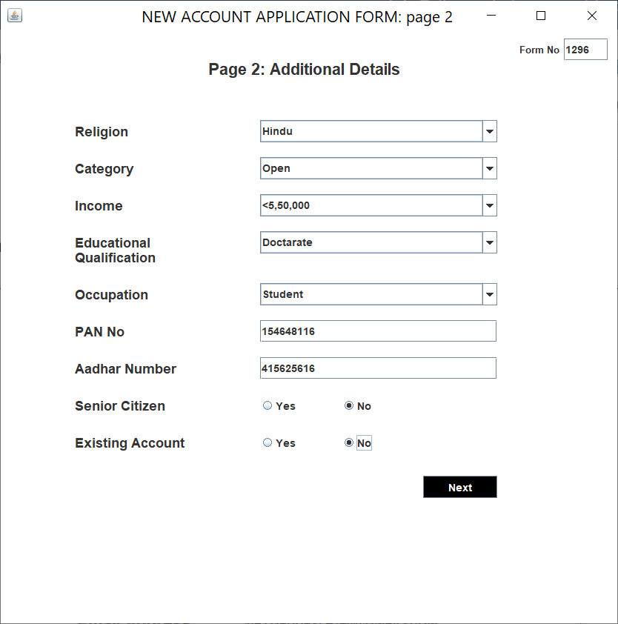

*Signup Form 3:*

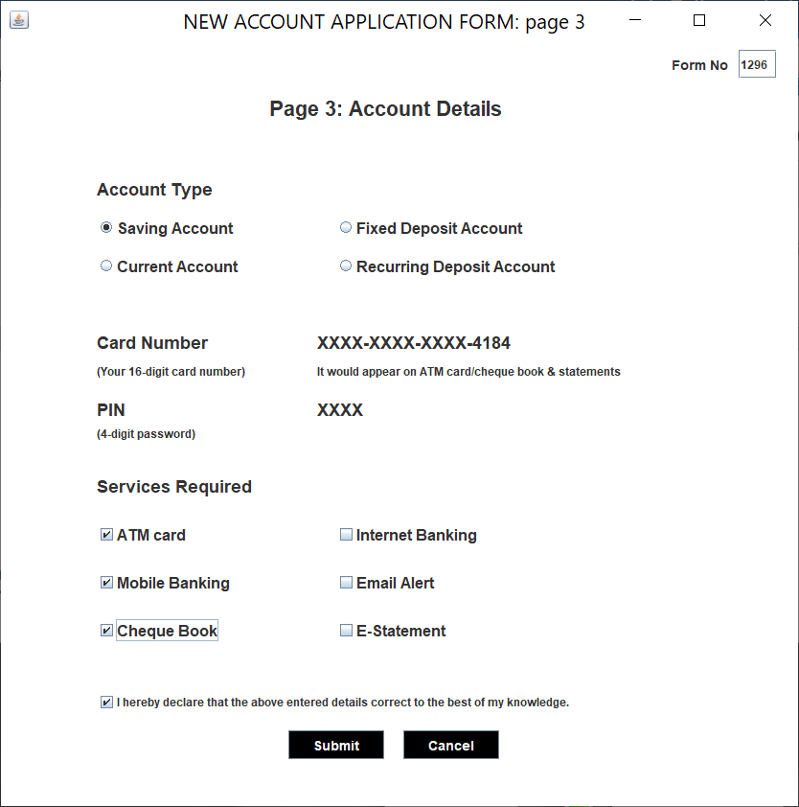

*Card no & PIN Generation:*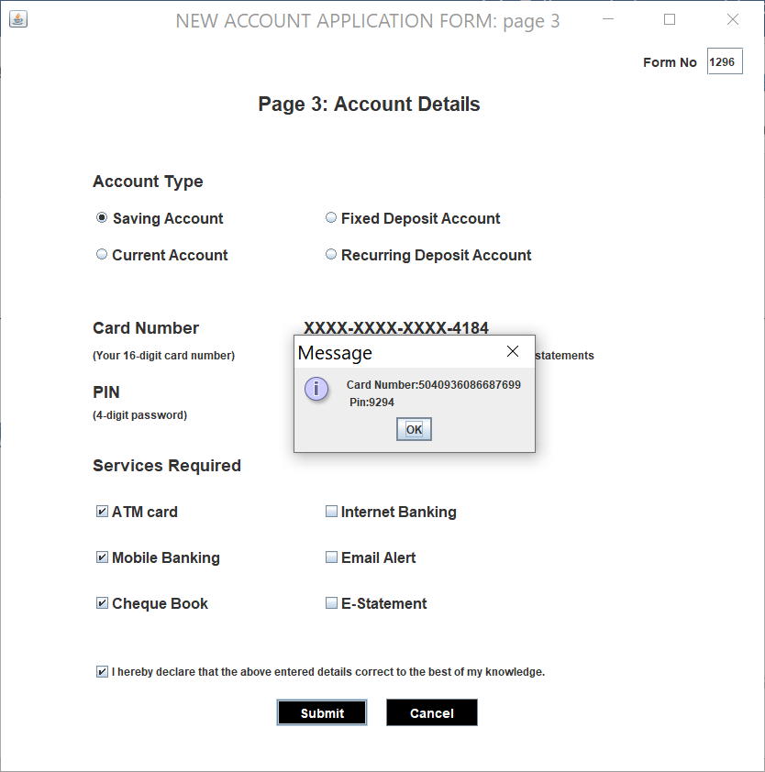

*Deposit form:*

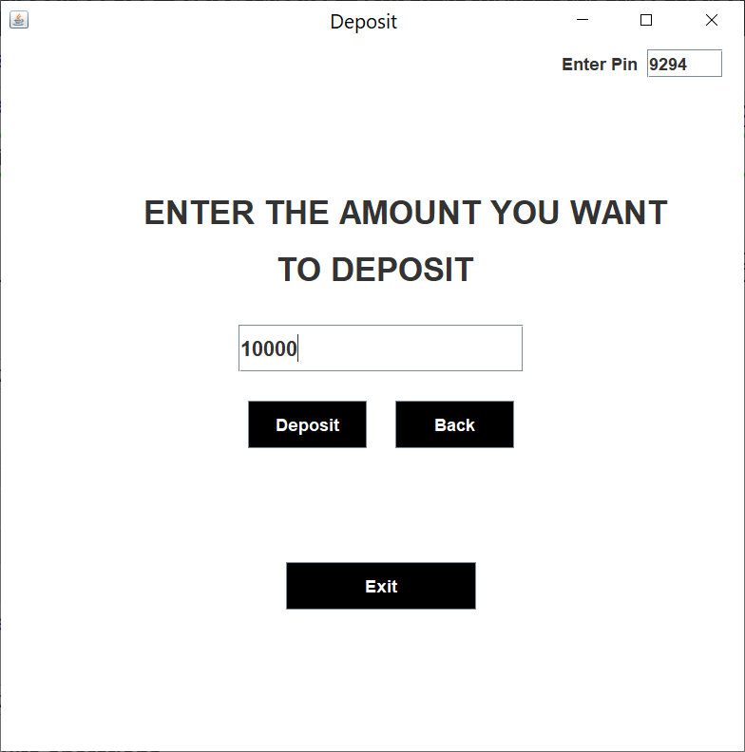

*Deposit process: Successful*

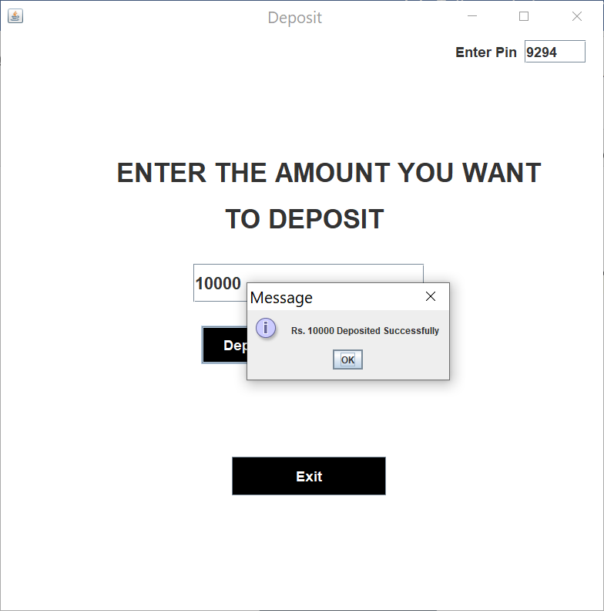

*Withdrawal Form:*

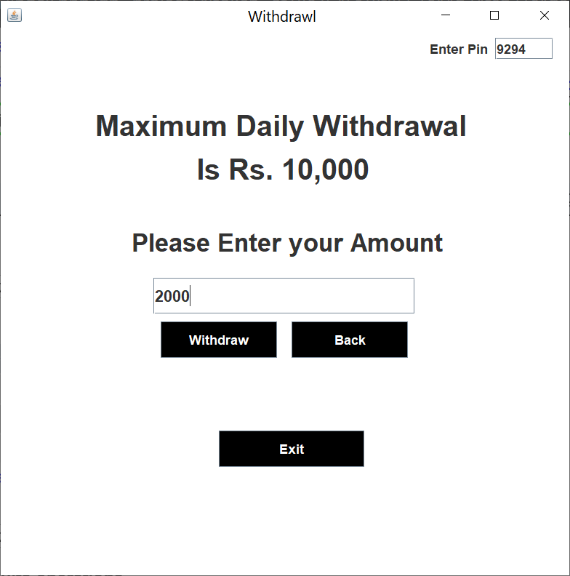

*Withdrawal process: Successful*

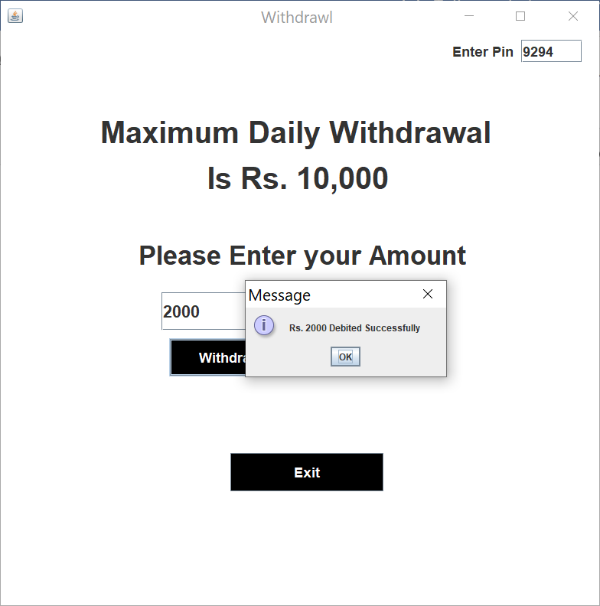

*Fast Cash form:*

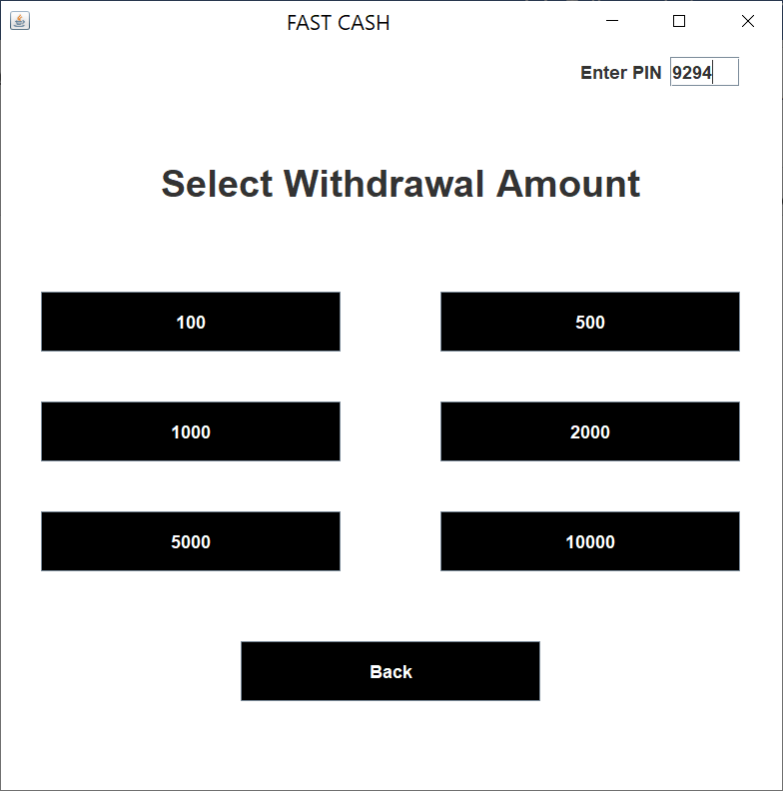

*Fast Cash form: Successful*

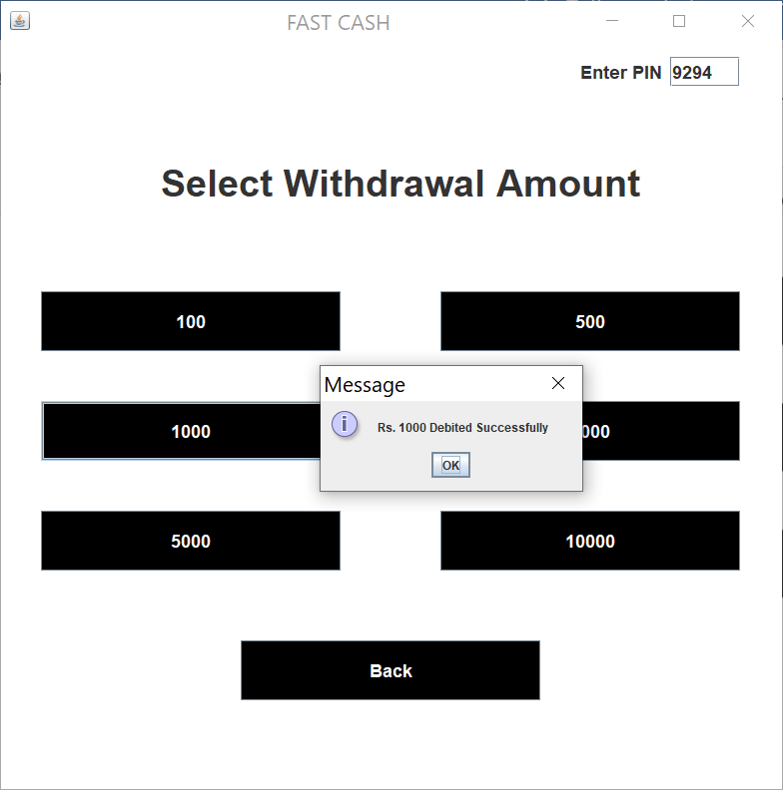

*Pin Change form:*

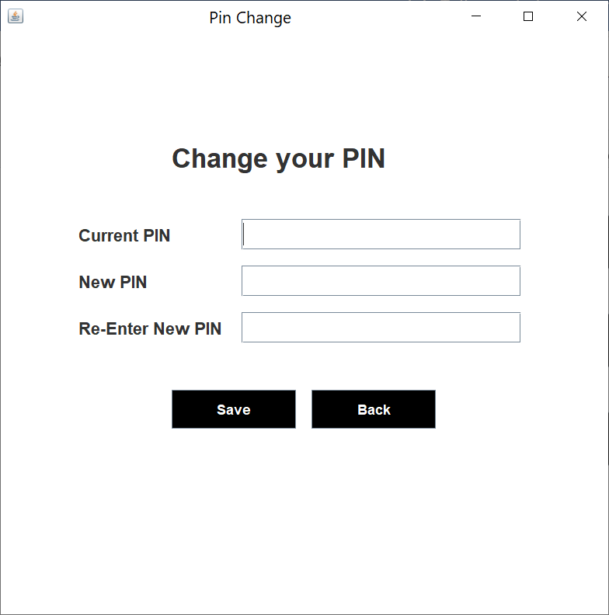

*Pin Change form: Successful*

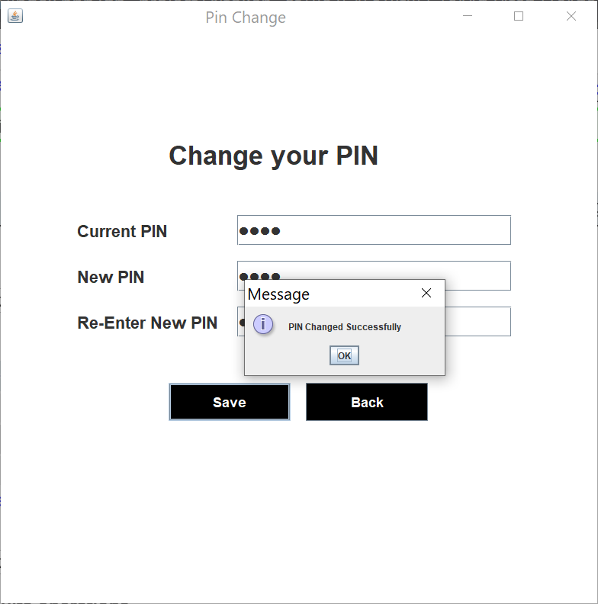

*Balance Enquiry Form:*

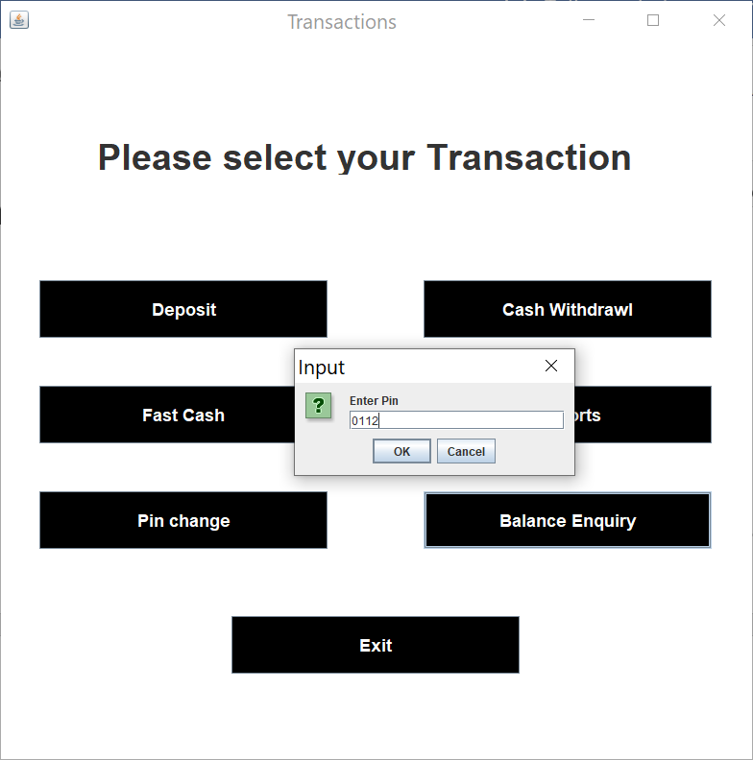

*Balance Enquiry Form: Successful*

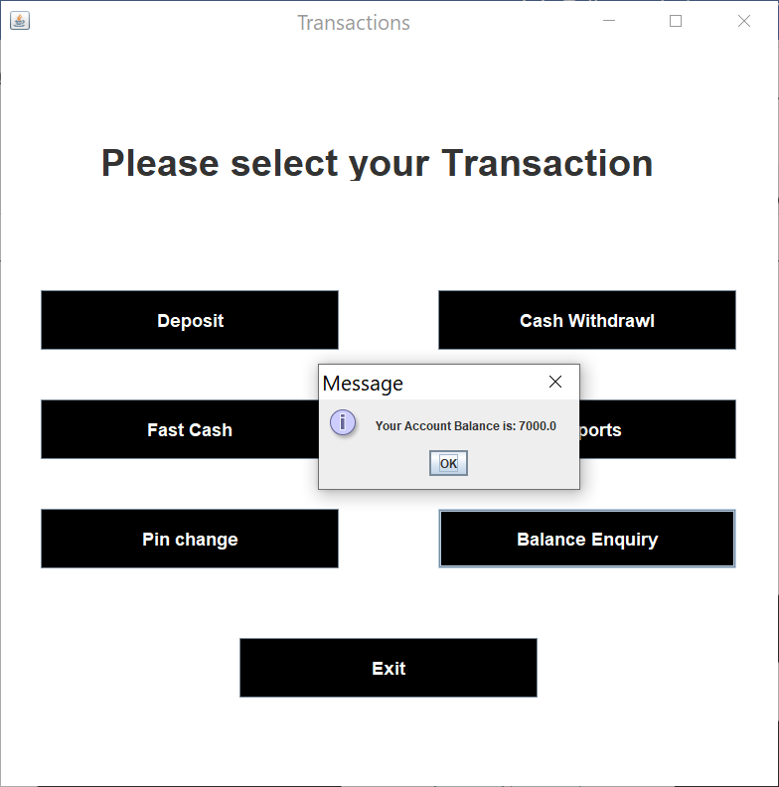

*Report Form:*

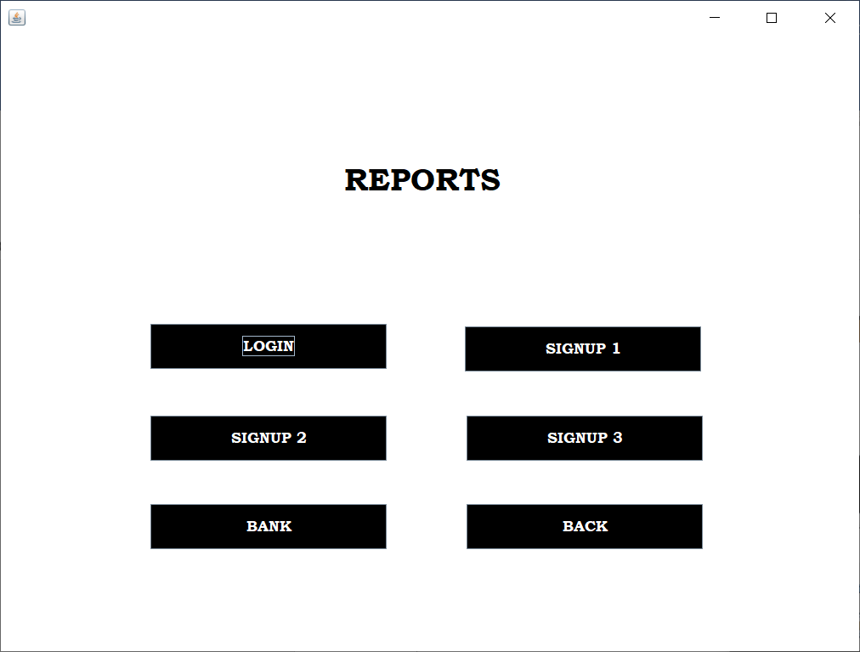

*Login Report:*

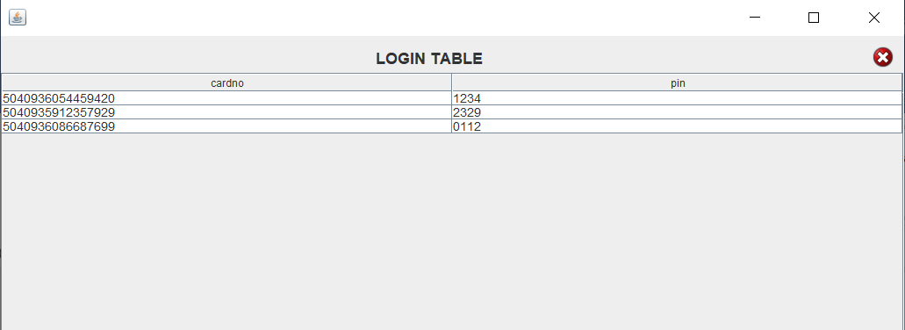

*Signup Report:*

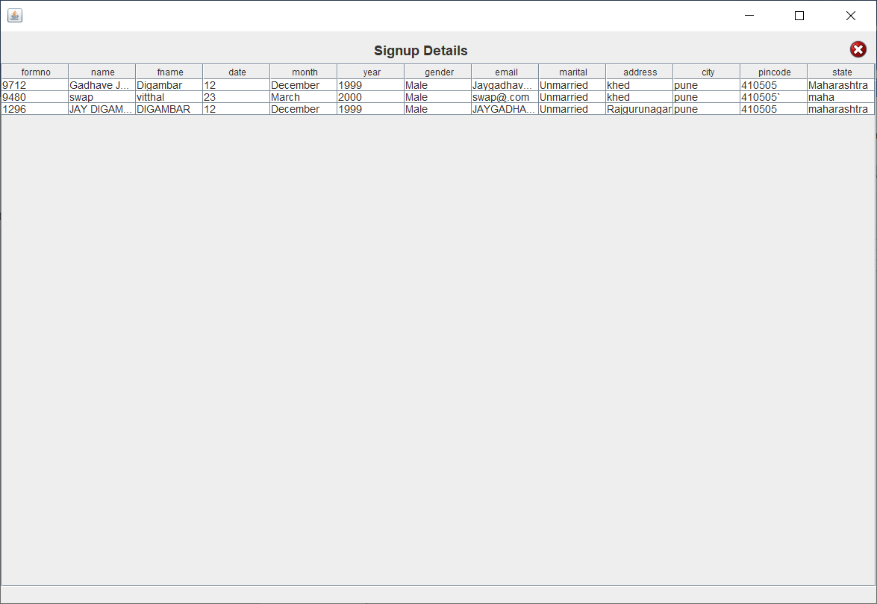

*Signup1 Report:*

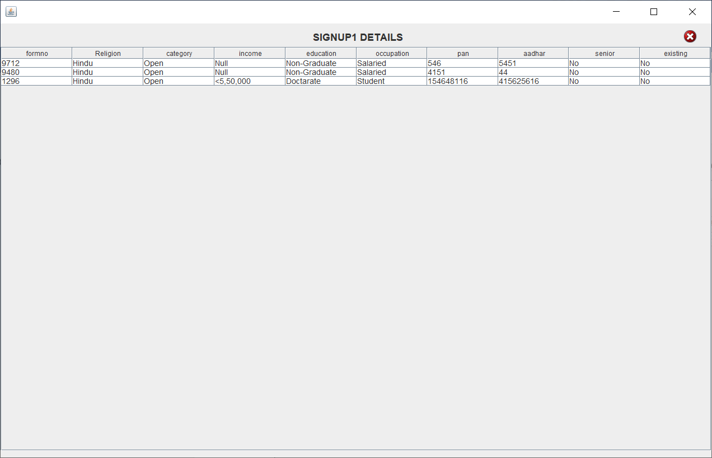

*Signup2 Report:*

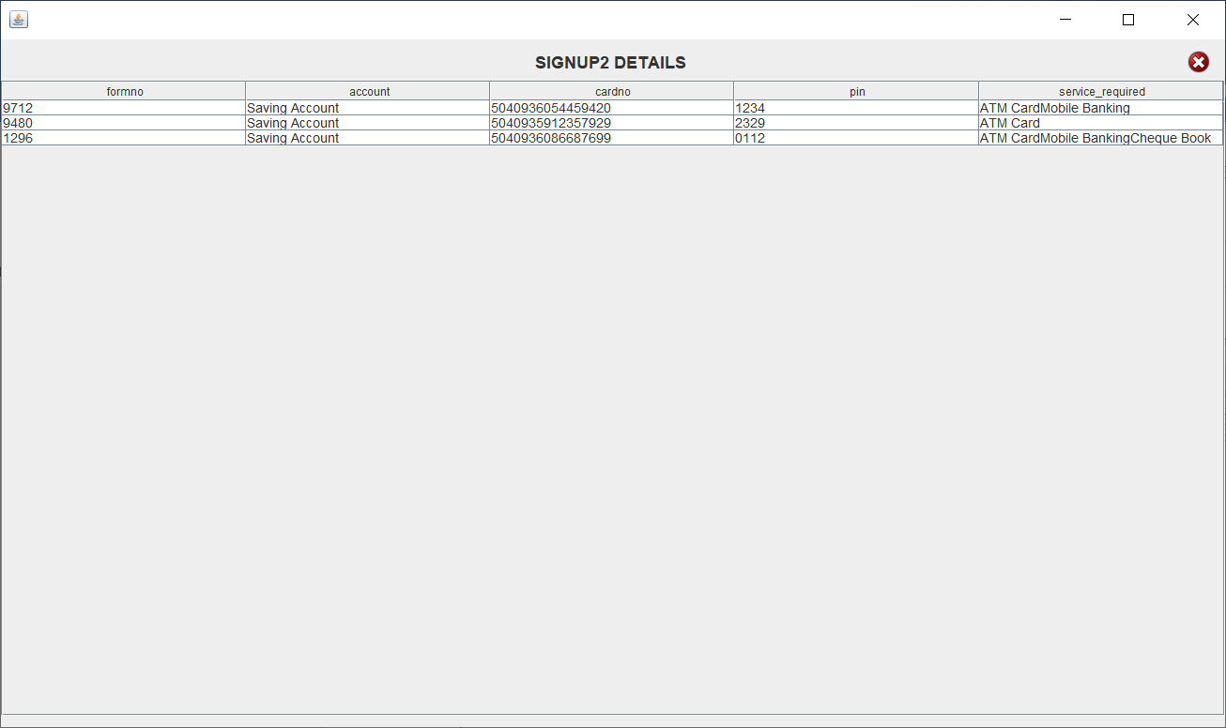

*Bank Report:*

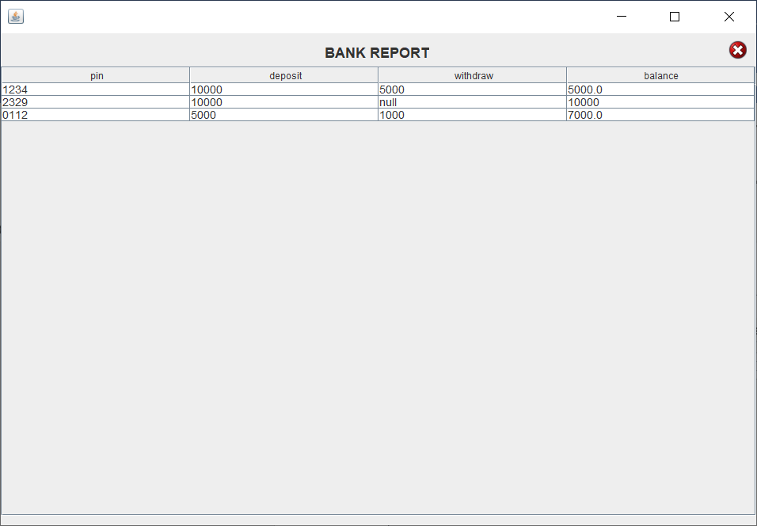

Advantages

* No need of bank employee for creation of account into bank.
* Time saving along with high quality services.
* Smooth and timely execution of reports.
* This management can also provide the report for every user.
* The records like Transactions, creating accounts and PIN change also retrieve afterwards.

**Future Enhancement**

This project was developed to fulfil user requirement; however there are lots of scope to improve the performance of the Banking System in the area of user interface, database performance, and query processing time. Etc.

So, there are many things for future enhancement of this project. The future enhancements that are possible in the project are as follows.

* Linking and integration of any legacy system for accounting.
* Integration with other bank and government agencies through Web Services
* Connection to third-party OLAP applications
* Electronic Data Interchange (EDI) system for ATM machine
* Web Interface for net banking.
* In the area of data security and system security.
* Provide more online tips and help.

***Bibliography***

* ***Websites:*** 
  + <http://www.google.com>
  + <http://www.docs.microsoft.com/java/languages>

​​

* ***Books:***
* Core JAVA
  + - Nirali Publication
* Software Engineering
  + - Vision Publication